“Know that the love that blooms
inside you
is stronger than fear.
For people who love
find strength they didn’t know they
had.
Know that the love inside you
is stronger than illness.
For people who love
hang in when physical health is gone.
And know that love is
indeed stronger than death.
For people who love
are like stones tossed into a pool.
The circles of love radiate out
and echo back
long after the stone has come to rest
at the bottom.”
Mark DeWolfe

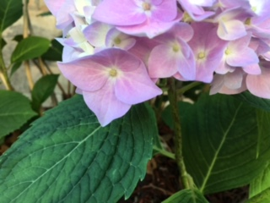

Books Related to Parent Loss:

Losing a Parent:
Passage to a
New Way of Living.
Alexandra Kennedy, March 5, 2013
Harper Collins-Publisher

Losing a Parent:
Practical Help for You and Other Family
Members. Fiona Marshall,
January 1, 2009 Da Capo Press Publisher.

Never the Same Coming to Terms with Death of a Parent.
Donna Schuurman, Ex. Director
of the Dougy Center for Grieving
Children and Families. (This book
is focused on the loss of a parent
as a child or adolescent).

How to Survive the Loss of a
Parent, A Guide for Adults.
Lois F. Akner C.S.W. with
Catherine Whitney.1993. William
Morrow and Company, NY NY

Letters from Motherless Daughters: Words
of Courage, Grief, Healing and Hope
Edelman, January 1, 2014
Perseus Books Group, Publisher.

“On Grief and Grieving: Finding the
Meaning through the Five Stages of Loss”
David Kessler and Elisabeth Kubler-Ross.

Karen Gore, LICSW
NVNA and Hospice
Bereavement Coordinator
781-659-2342
nvna.org

